**Will Jeep’s Wagoneer S and Recon Define EV Off-Roading?**

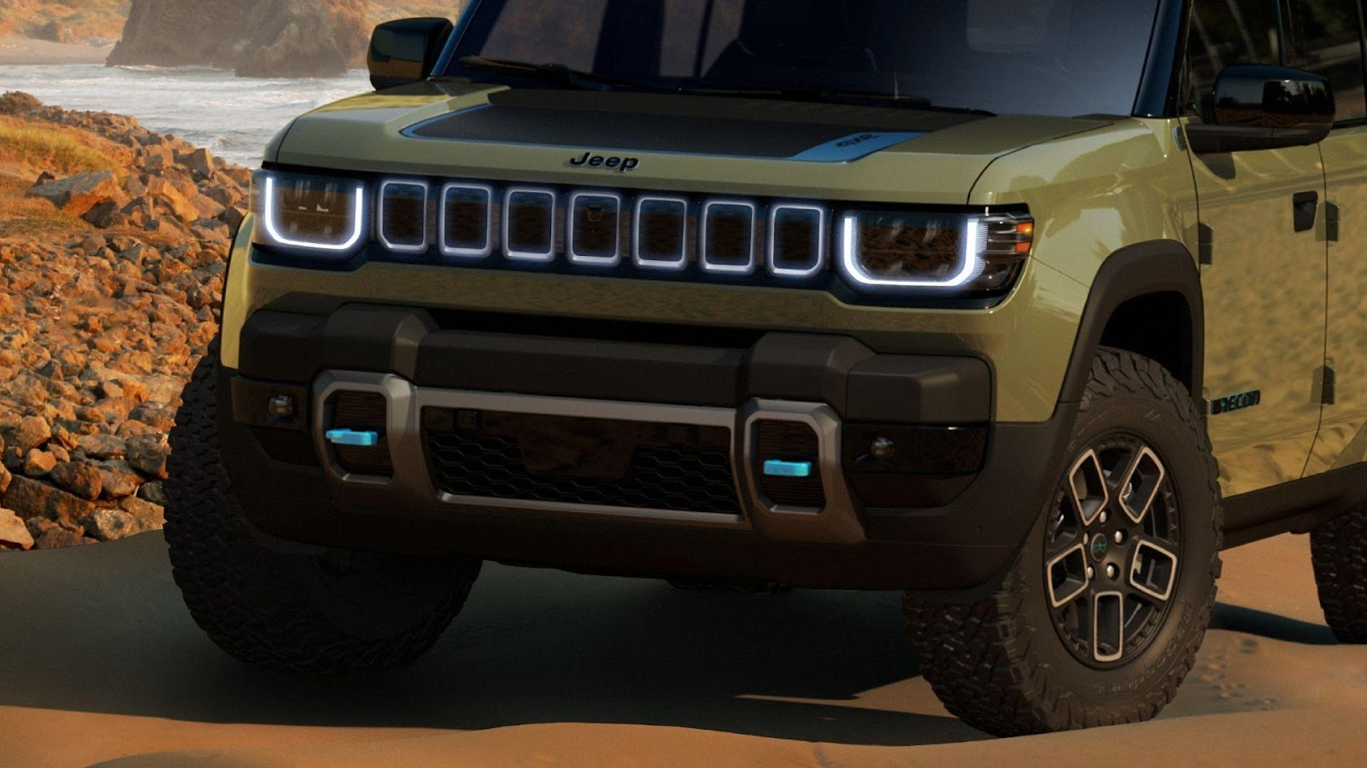

Few brands carry off-road heritage quite like Jeep. From World War II battlefields to muddy weekend trails, the nameplate has symbolized mechanical simplicity, rugged capability and go-anywhere confidence. But as the auto industry transitions toward electrification, Jeep is attempting something bold: making EVs part of its core identity. That future is no longer hypothetical. As of mid-2025, the [**Jeep Wagoneer S**](https://carbuzz.com/cars/jeep/wagoneer-s/) is already on sale across North America, delivering 600+ horsepower and luxury EV performance in a brand-new shape.

Meanwhile, the more rugged [**Recon EV**](https://carbuzz.com/jeep-recon-trail-rated/) is moving through production, with showroom arrivals expected before the end of the year. These two electric SUVs represent Jeep’s first serious entries into battery-powered adventuring. One’s a street-focused missile; the other is gunning for Wrangler cred with removable doors and rock-ready hardware. The big question: Can they really live up to Jeep’s legacy — or does electrification fundamentally change what “Trail Rated” means?

**Jeep’s EV Future Is Already Here**

[Jeep’s EV program moved fast](https://www.cnn.com/2024/05/12/business/jeep-evs-recon-wagoneer-s/index.html). The **Wagoneer S** debuted in late 2024 and officially launched in early 2025. Based on Stellantis’ STLA Large platform, it's Jeep’s first ground-up electric SUV and is already available at U.S. dealers. The **Recon**, on the other hand, is still ramping up. Production began in early 2025 and customer deliveries are expected in the final quarter of the year.

Despite the wait, anticipation is high. The Recon is built to channel the spirit of the Wrangler into an electric platform, not just mimic it. [Both models are more than concept cars](https://www.reuters.com/business/autos-transportation/stellantis-unveils-ev-strategy-us-focus-jeep-lineup-2024-05-10/) — they’re volume products, each designed to hit core segments: upscale family SUVs and hardcore off-roaders. Jeep isn’t dipping a toe in the water; it’s staking a claim on the EV trail.

**Wagoneer S: Performance Over Posing?**

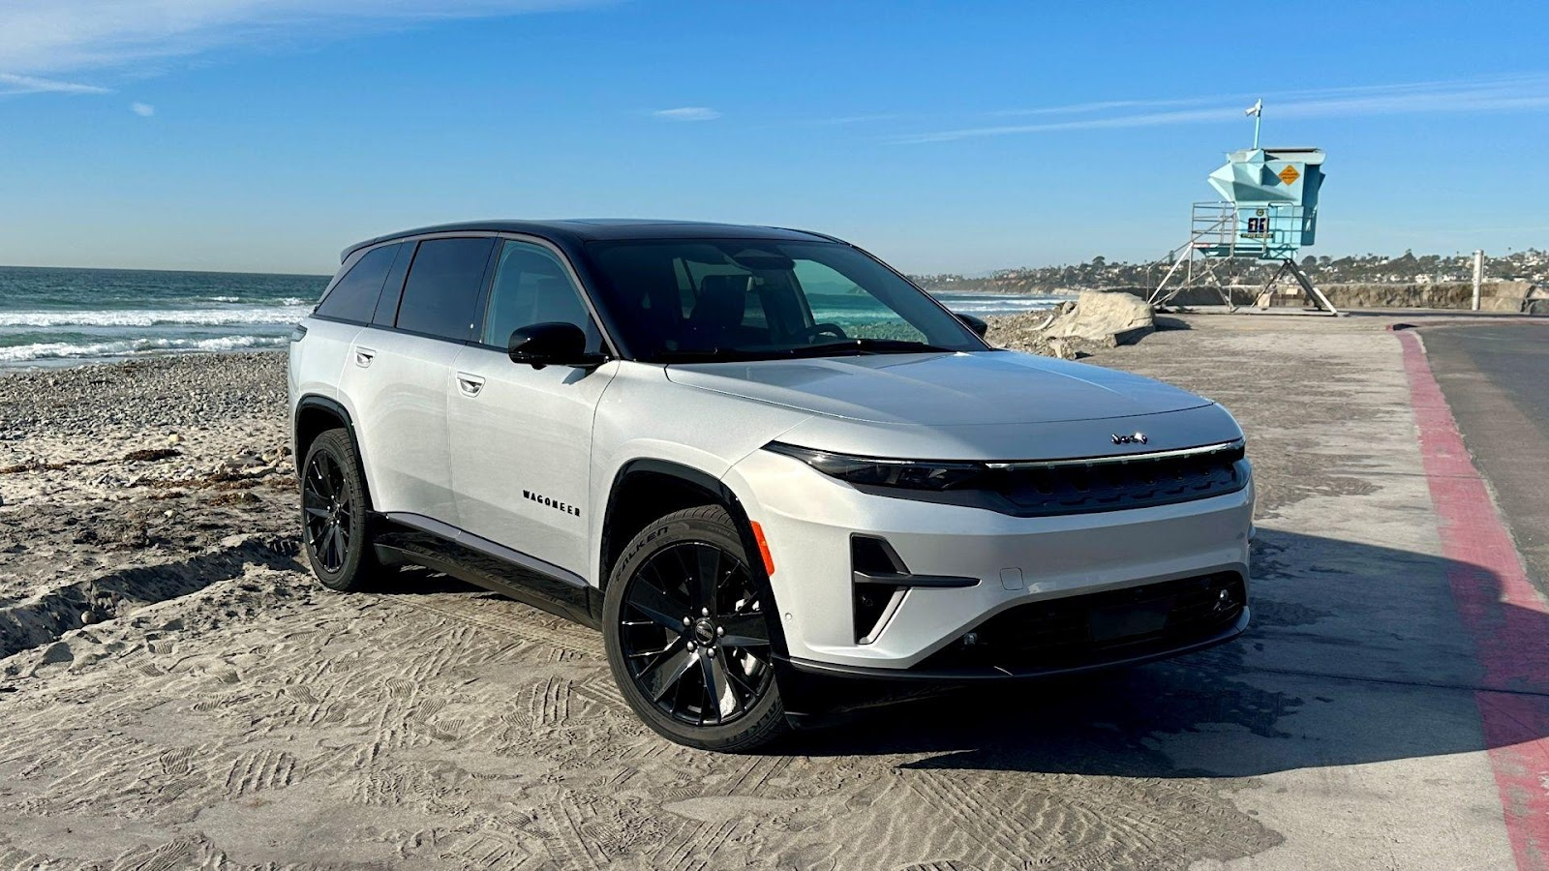

The Wagoneer S is a new take on Jeep luxury: sleek, minimalist and brutally fast. It’s not boxy like its namesake but takes design cues from crossovers and performance EVs. Think slim LED lighting, flush surfaces and a reimagined grille. Jeep claims it will hit **60 mph in just 3.4 seconds**, making it the **most powerful Jeep ever produced**, eclipsing even the 707-hp Grand Cherokee Trackhawk. That’s thanks to a **dual-motor, all-wheel-drive setup** pushing out over **600 horsepower**. Estimated range sits north of **300 miles**, with rapid DC fast charging capabilities built in.

While not a hardcore off-roader, the Wagoneer S comes with adaptive ride height, terrain modes and traction systems built for inclement conditions. It’s more snow trail than Moab crawl, but Jeep insists it still deserves the badge. With 600+ hp and a sub-4-second sprint time, the Wagoneer S redefines what luxury EV performance looks like, while still carrying genuine off-road DNA.

**Recon: A Wrangler Reboot With a Battery Pack**

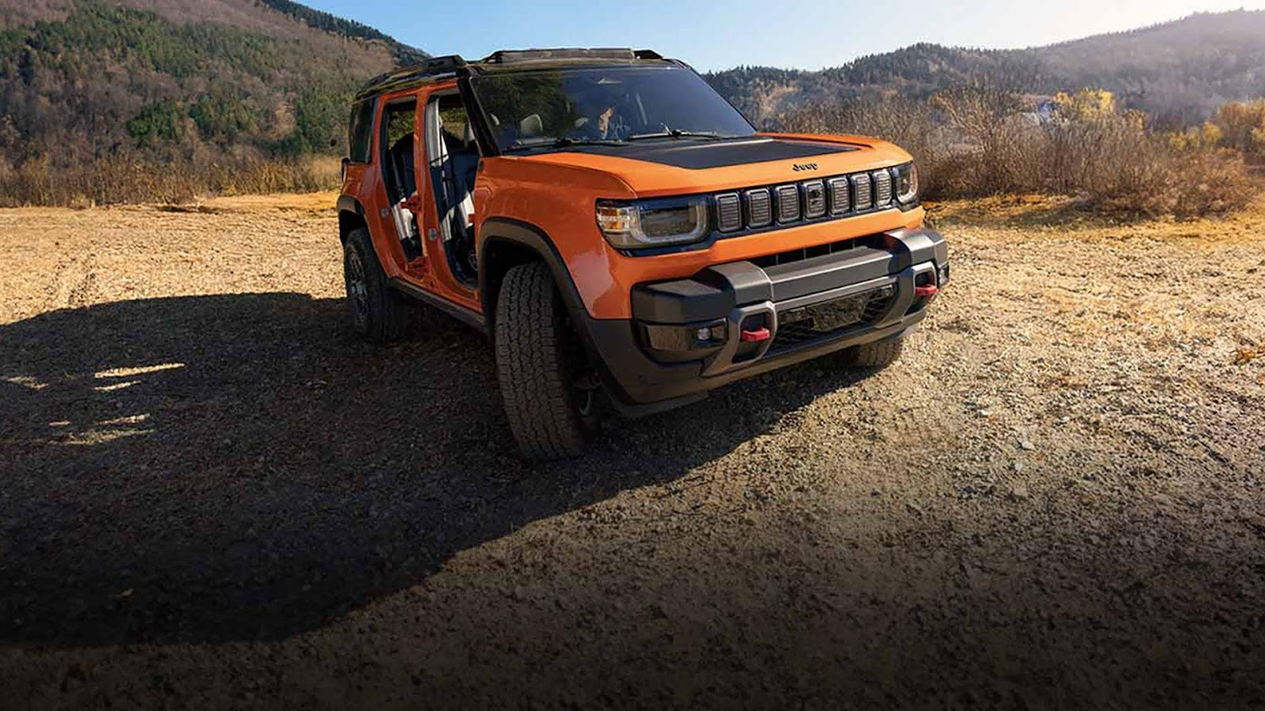

Unlike the street-slick Wagoneer S, the **Recon** has no interest in subtlety. This boxy EV SUV is being positioned as an [all-electric alternative to the Wrangler](https://carbuzz.com/jeep-wrangler-legacy-on-the-recon-shoulders/), complete with **removable doors**, a **fold-back roof** and **locking differentials**. Jeep is designing the Recon to carry over the most iconic elements of the Wrangler, targeting off-road enthusiasts who expect real capability. It will feature Selec-Terrain drive modes with a dedicated Rock setting, along with high ground clearance and short overhangs that preserve strong approach and departure angles. Trail-rated hardware like skid plates and aggressive off-road tires reinforce its readiness for rugged terrain. To support more advanced exploration, Jeep is also integrating trail navigation software with offline maps and waypoint tracking, designed for drivers who venture well beyond cell coverage.

Built on the same STLA Large platform, the Recon trades power for precision. Official horsepower numbers haven’t been published yet, but estimates hover between **300–400 hp**, with a targeted range of **250–300 miles**. Fast charging and torque-vectoring are expected standards. Most importantly, Jeep engineers have spent time testing it on actual trails – including portions of the Rubicon – ensuring it meets the demands of its enthusiast base. The Recon isn’t just a Wrangler tribute – it aims to be a fully capable successor.

**Specs Recap: Jeep’s EV Lineup at a Glance**

**Vehicle Horsepower Range (Est.) Key Features**

Wagoneer S 600+ hp ~300+ miles Dual-motor AWD, 0–60 in 3.4s, adaptive ride height

Recon 300–400 hp (est.) ~250–300 mi Removable doors, trail-ready, offline nav, locking diffs

**Off-Roading Without the Drama – Is It Still Jeep?**

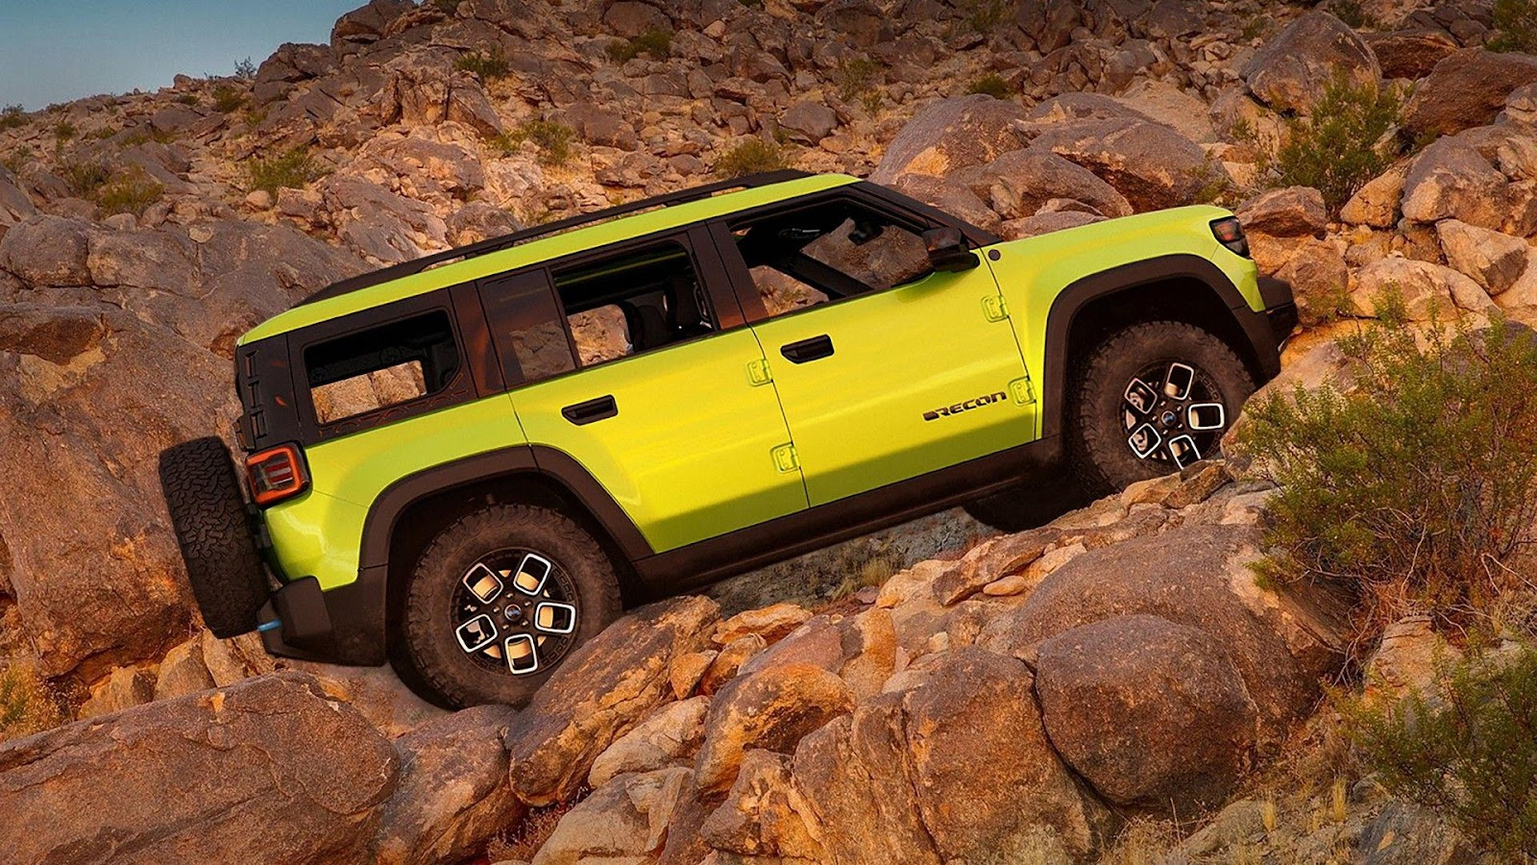

One of the biggest cultural questions Jeep faces isn’t about specs – it’s about *feel*. Off-roading has always been a visceral experience. You hear the engine strain, feel the suspension flex, smell the fuel. Electric drivetrains erase much of that sensory engagement. And yet, they add something new: **immediate torque**, **precise control** and **fewer mechanical vulnerabilities**. EVs don’t need transmissions, don’t stall on inclines and can distribute power to each wheel with algorithmic precision.

For the Wagoneer S, this translates to fast, stable travel across mixed terrain. For the Recon, it could mean real-time torque shaping and traction strategies that outperform even mechanically locked axles. The result is control without commotion. Still, purists will miss the rumble. The question is whether the **feel of confidence and capability** can replace the **sound of effort and grit**.

**Charging, Range and the Realities of Trail Life**

Remote trails don’t come with charging stations, and Jeep knows it. That’s why both the Wagoneer S and Recon are built with serious trail-minded features to handle off-grid challenges. They’ll support rapid top-ups with charging speeds up to 350 kW, ideal for quick stops when a plug is available. Regenerative braking will be tuned for downhill control, helping recover energy on steep descents.

To make each kilowatt count, Jeep is also introducing trail battery management modes that dial back power draw and preserve range during technical crawls and low-speed climbs. The Recon’s trail navigation system with offline mapping is particularly key. It lets users pre-plan loops based on elevation, terrain and expected battery draw – much like fuel range calculators in overlanding apps today.Expect future overlanding accessories like solar chargers and portable battery extenders to follow.

**A New Direction, Not a Replacement**

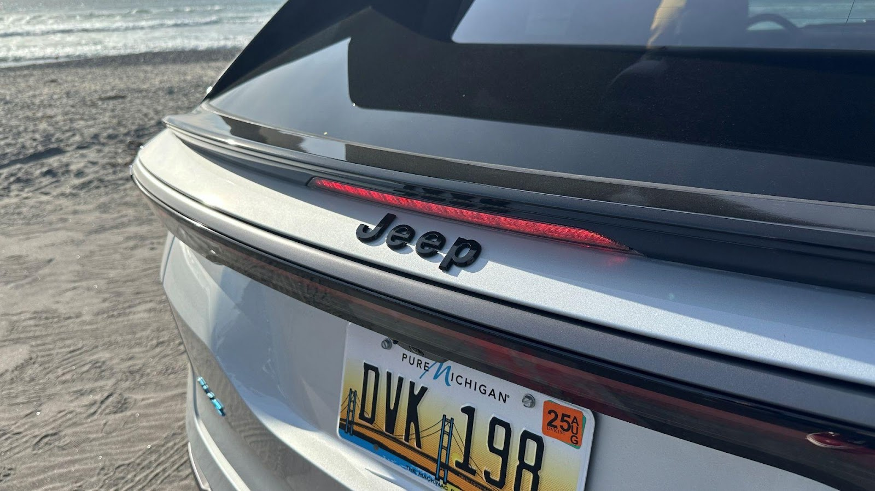

Jeep is not abandoning its gasoline core – Wrangler, Gladiator and ICE Grand Cherokee models remain critical to its lineup. But the Wagoneer S and Recon represent the brand’s most ambitious step into electrification yet.

The real goal? [Expand the meaning of Jeep ownership for a new generation](https://carbuzz.com/jeep-charts-new-terrain-with-the-wagoneer-s/). These EVs are aimed not just at long-time off-roaders, but at urban adventurers, younger buyers and eco-conscious consumers who want to play outside without leaving a carbon footprint behind. The Recon and Wagoneer S won’t replace Jeep’s past. But they may well define its future.

**Why the Mercedes G580 EV Is the Off-Road Icon We Never Expected**



When Mercedes-Benz announced it was electrifying the G-Class, reactions ranged from skepticism to outright disbelief. How do you take one of the most iconic, gas-guzzling off-roaders in automotive history, the G-Wagen and turn it into a battery-powered SUV without losing its soul?

Enter the [2025 Mercedes-Benz G580 with EQ Technology](https://carbuzz.com/2025-mercedes-benz-g58-with-eq-technology-first-look-review/). On paper, it’s a contradiction: nearly 7,000 pounds of silent electric luxury, priced over $160,000, with no internal combustion engine in sight. But on trails, on city streets and even on spec sheets, the G580 proves it’s more than just an electrified tribute act. It’s a fully realized evolution – familiar in form, shockingly capable in function.

**A Familiar Shape, Reinvented Beneath the Surface**

At a glance, [the G580 looks like a G-Class should](https://www.mbusa.com/en/vehicles/build/g-class/suv/g580w4e). Boxy. Upright. Purpose-built. The iconic exposed door hinges and flat panels remain. But the biggest changes are hidden below the surface. Instead of a twin-turbo V8, the G580 uses four electric motors, one per wheel, fed by a 116-kWh lithium-ion battery pack mounted under the floor and protected by a composite skid plate. This quad-motor setup delivers **579 horsepower** and an astonishing **859 lb-ft of torque**. That’s more than the V8-powered G550 or even the AMG G63. It’s also enough to send this **6,800-pound SUV from 0–60 mph in under 4.7 seconds**.

What’s particularly interesting is how these raw numbers translate to everyday usability. Unlike typical EVs, the G580 employs a simulated low-range gearbox and independent motor control, enabling torque vectoring, trail crawl modes and even the eye-catching “G-Turn” – a tank-like 360-degree spin on loose surfaces.

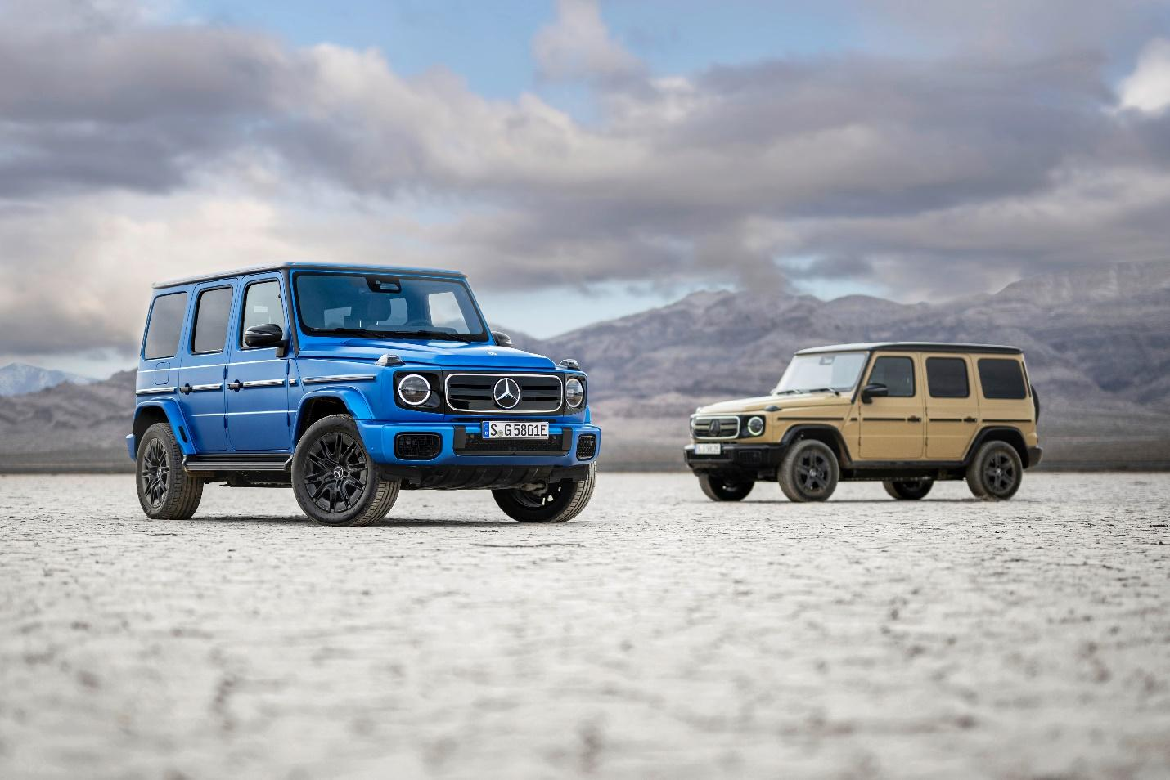

[Here’s how it stacks up on paper](https://carbuzz.com/cars/mercedes-benz/g580-with-eq-technology/):

**Specification G580 EQ**

Power 579 hp

Torque 859 lb-ft

Battery Capacity 116 kWh

EPA Range ~238 miles

0–60 mph ~4.6 seconds

Ground Clearance 9.8 inches

Approach/Departure 30.7° / 30.2°

Starting Price ~$162,000+

**Note:** The G580 delivers more torque than any G-Class in history, yet it’s also the quietest.

**Off-Road Credibility That Goes Beyond the Badge**

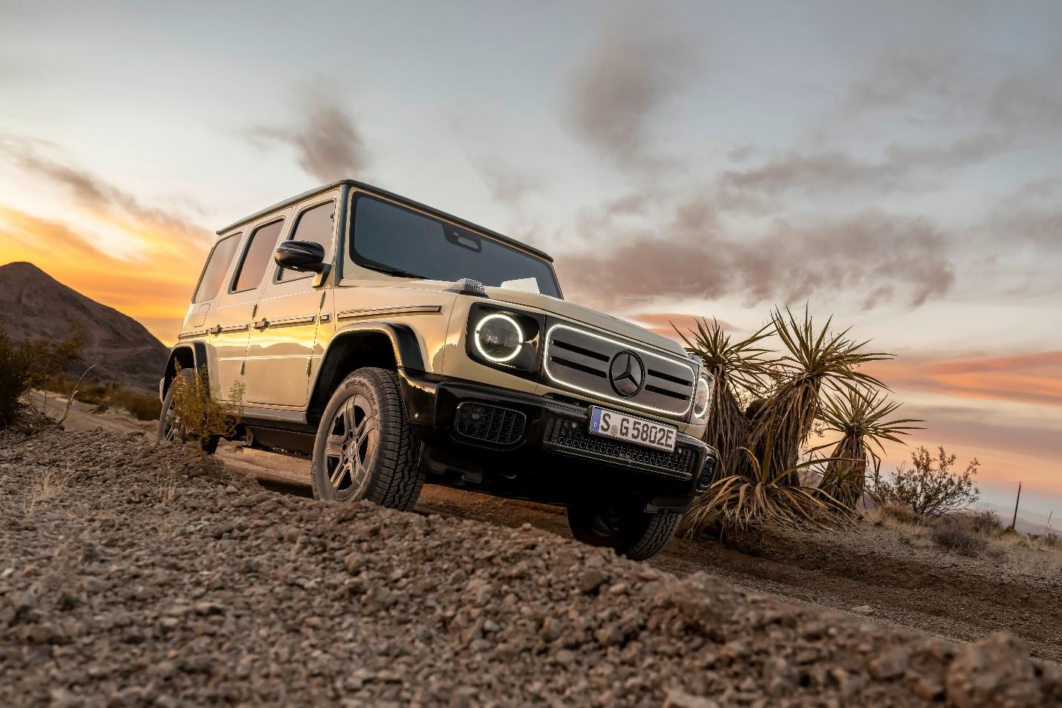

The G580 doesn’t just wear the off-road badge; it earns it. Mercedes engineers preserved the G-Class’s ladder-frame architecture but re-engineered it to accommodate the battery’s weight and protection. The result is a platform that’s both stiffer and more balanced than its gas-powered siblings. [Off the beaten path, the electric G-Wagen is remarkably confident](https://carbuzz.com/biggest-new-changes-to-2025-mercedes-benz-g-class/). With **9.8 inches of ground clearance**, **30+ degree approach and departure angles** and the ability to wade through over **33 inches of water**, the G580 keeps up with (and in many cases outperforms) its gas-powered siblings on technical terrain.

The absence of engine noise adds a new kind of thrill, letting you hear the tires bite into dirt or rocks skip beneath the belly plate. It's a more immersive form of off-roading. With drive modes calibrated for gravel, sand and rock and the ability to individually modulate power at each wheel, the G580 offers something few EVs do: nuance. Most electric SUVs focus on traction; this one offers true articulation and control.

**On the Road: Smooth, Silent and Surprisingly Engaging**

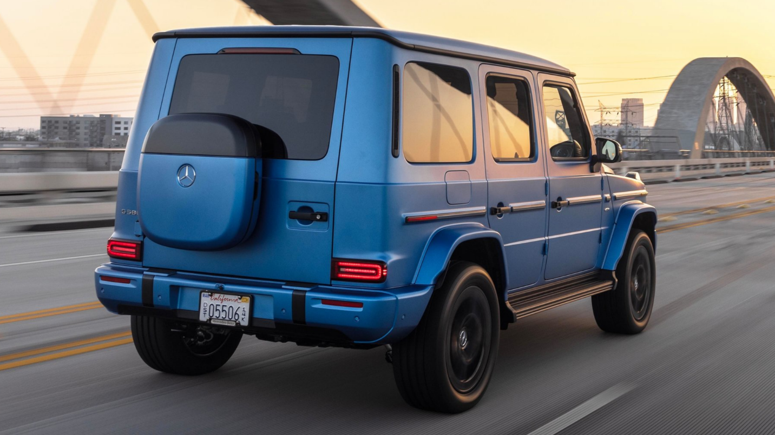

[Around town, the G580 drives like a G-Class should](https://www.wsj.com/lifestyle/cars/2025-mercedes-benz-electric-g-580-ev-review-0a-reformed-gas-guzzler-reviewed-a82d5d58) – commanding, luxurious and brimming with presence. But thanks to the electric drivetrain, it’s also eerily quiet and incredibly smooth. Without the vibration of a V8 under the hood, the cabin is a sanctuary. The acceleration is immediate. The ride is refined. And the **G-Roar** sound generator, a synthetic exhaust note pumped through the speakers, adds a touch of character. It's not meant to mimic the old V8 exactly, but it does inject a little theater into an otherwise hushed experience.

Despite the weight, the G580’s center of gravity is lower than a gas G-Wagen, which improves body control and high-speed stability. Still, it's not exactly nimble. The steering remains heavy, the turning radius is tight but not car-like and full one-pedal driving is absent. Instead, you get gentle regenerative braking that works best in moderate city traffic. **Real-world range hovers around 200 miles**, making this more of a lifestyle machine than a long-distance touring rig. Mercedes clearly designed the G580 for short luxury commutes and weekend escapes – not extended overlanding.

**Inside: Vintage Charm Meets Digital Luxury**

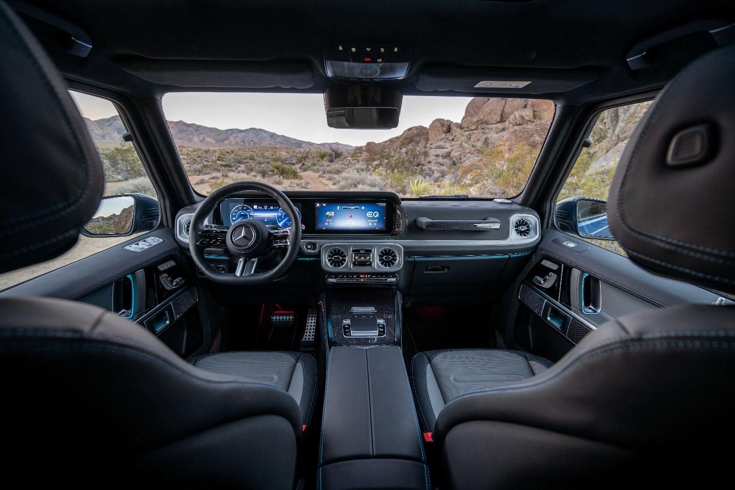

[Step inside and it’s classic G-Wagen meets modern luxury](https://www.mbusa.com/en/future-vehicles/2025-mercedes-benz-electric-g-class). The upright dashboard and passenger grab handle remain, but the twin-screen **MBUX infotainment system** dominates the interior. Material quality is what you'd expect at this price point – plush leather, metal switchgear, customizable ambient lighting.

Unique to the electric model is a **"Digital Wheel"** on the rear tailgate. Instead of housing a spare tire, it cleverly stores charging accessories, adding a futuristic nod to the traditional design. It's one of several subtle changes that keep the G580 grounded in its heritage while modernizing its purpose. Rear-seat comfort is strong and while cargo space isn’t class-leading, it’s usable for everyday needs. Optional rear entertainment and premium Burmester audio round out the package.

**Verdict: A Reinvention That Works**

Mercedes didn’t just electrify the G-Class. It reimagined it. The G580 with EQ Technology is proof that an EV can retain heritage while pushing boundaries. It’s fast. It’s shockingly capable. It’s deeply luxurious. And it’s still, unmistakably, a G-Wagen.

But it’s not for everyone. The price tag is steep. The range is modest. And it’s more of a lifestyle statement than a practical EV for the masses. Still, for buyers who want old-school cool with zero tailpipe emissions, the G580 offers something rare: authenticity without compromise. This move shows that Mercedes is committed to its legacy, even as it quietly evolves to meet the future.